# Report for Travis Quink (2024-10-01 to 2024-10-31)

Average Bat Speed: 49.94

Average Rotational Acceleration: 5.24

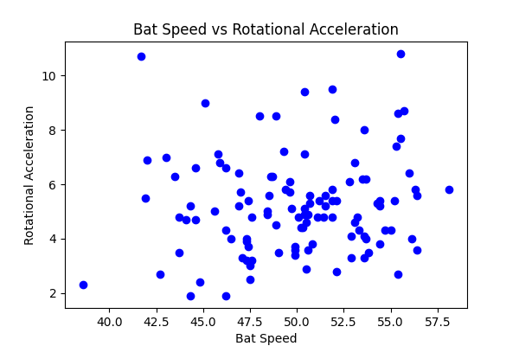

## Comments

Add comments here...